Mobile Solutions Capstone Project (PROG8225)

**Queue Master**



**Team Members:**

Kavitha Vijayan (8663128)

Amritpal Singh Paramjeet Singh Kalsi (8630937)

Jaspreet Kaur Sekhon (8631793

Supervised by: Aagam rajeshkumar Jhaveri

Mobile Solutions development

Conestoga College

Technical Report

Table of Contents

Abstract 3

Introduction 3

Features 4

Effective queue management: 4

Providing customer support: 4

Adding features and updating the application as per the requirement: 4

Shops 4

Future plans: 4

In-App purchase: 4

Advertisements: 4

Use case diagram 5

Class diagram 5

Sequence diagram 6

About Queue master 7

**Sign Up Page:** First is the register page in which user can create account or can switch to the sign in page if already have an account 7

**User Account:** User can edit the account like password can add picture or name 7

**Queue Configuration:** Shops can configure a queue and can add their description for the customers, like name location which helps customers to find on map and description and estimate wait time. 8

Database 9

Conclusions 11

References 11

# Abstract

This application is built for android devices. It is used to locate places for buying essential items and can purchase from doorsteps or curb side pickup. It is based on token system that means it will generate token for the customers and an estimated wait time for them. It is Easy to use as no technical knowledge is required to use this application. This application will fully support any android device.

In this application we used Java, Android for the development of the application and Extensible Markup Language (**XML**) and Material Design for Application designing and firebase for the database.

This application is developed to Assist the public so that during this pandemic they can properly and safely tackle the situations.

To develop an application that can be used for the betterment of people during these difficult times so that during pandemic everyone will be able to be safe and protected.

# Introduction

Long queues outside stores are very common now. We don’t have to stay in time consuming and energy draining queues anymore. This idea will help everyone who goes shopping and to get any kind of services and those who don’t like to wait in long queues. Long queues to get any service due to COVID 19. By implementing our idea people can save time and energy. It is difficult for people to stay outside for long in challenging weather. Some people might want to buy just one or two items. It is really frustrating to stay in long queues for that. For example, grocery shopping, which happens frequently. It’s frustrating and time consuming to stay in long queues. The customer can feel that even going for grocery shopping is a burden to themselves. They could get a feeling that they could have use that time for something productive. They don’t have to stand in queue for long and will not waste customer time. It brings back the convenience is the shopping. Also, we are implementing physical distancing also by making people not stay around.

# Features

## Effective queue management:

The queue will be managed properly to avoid misunderstanding and chaos, as well as the overcrowding.

## Providing customer support:

Customer support and assistance will be provided to the customers as per their needs.

## Adding features and updating the application as per the requirement:

Implementation and updating of the Application will be done on a regular basis to provide a better user experience.

## Shops

Revenue will be generated from the shop maintaining teams as well as the organizing committee of an event who wants to manage the public and queues.

# Future plans:

## In-App purchase:

in-app purchases are the purchases the users can make to make changes to the application as such if a user doesn’t want to see the annoying ads and pop-ups so he can upgrade the services of the application by paying for the application after which ads will be completely removed from the application.

## Advertisements:

Ads will be shown in the application as pop-ups and banners so the revenues can be generated from the businesses and the organizers who want to publish their ads on our application.

# Use case diagram

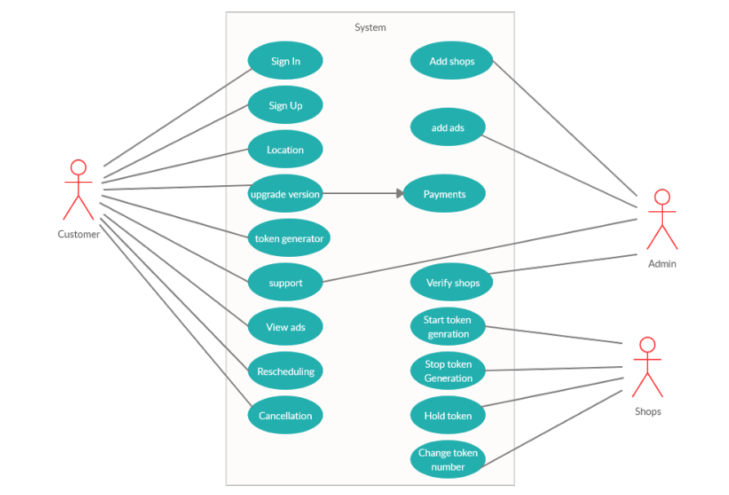

# Class diagram

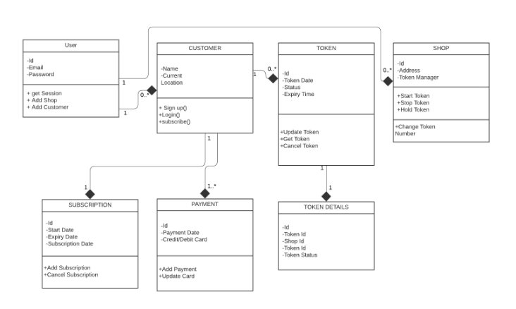

# Sequence diagram

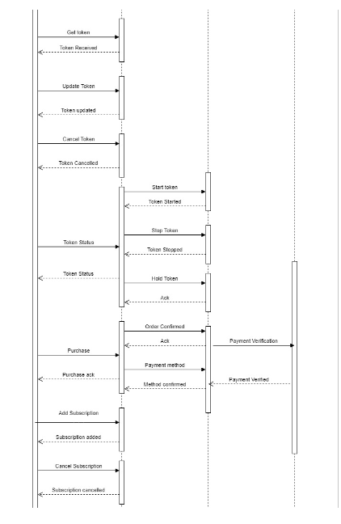

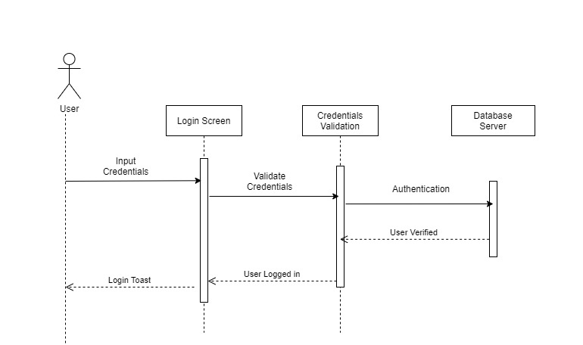

# About Queue master

## **Sign Up Page:** First is the register page in which user can create account or can switch to the sign in page if already have an account

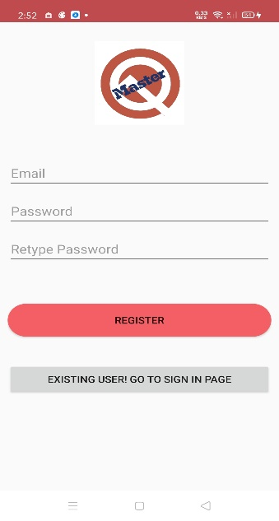 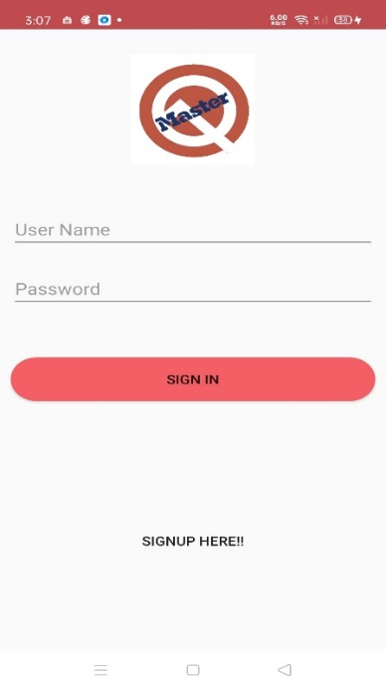

## **User Account:** User can edit the account like password can add picture or name

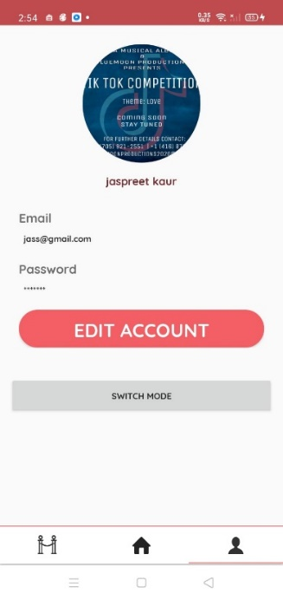

## 

**Switch Account:** Can switch to customer to shop or from stop to customer

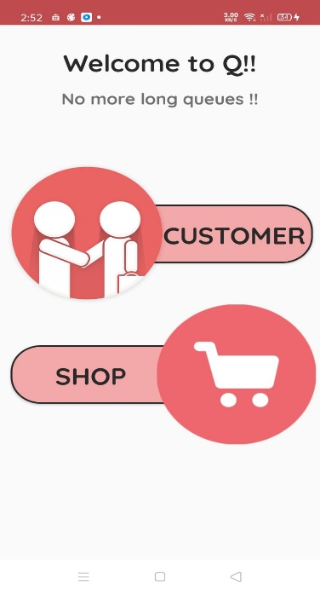

## **Queue Configuration:** Shops can configure a queue and can add their description for the customers, like name location which helps customers to find on map and description and estimate wait time.

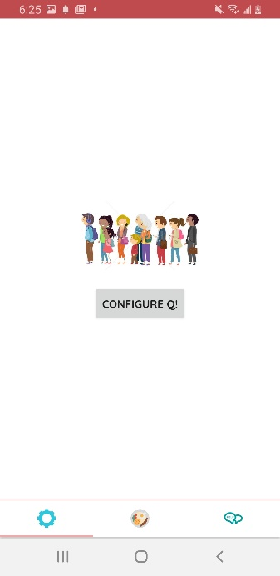 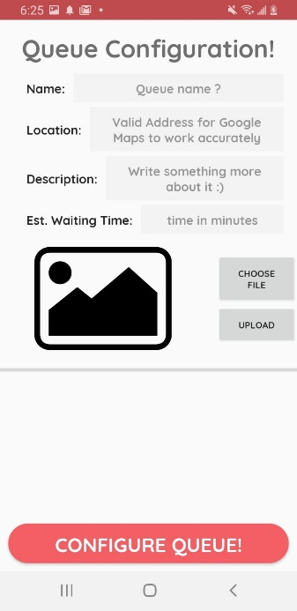 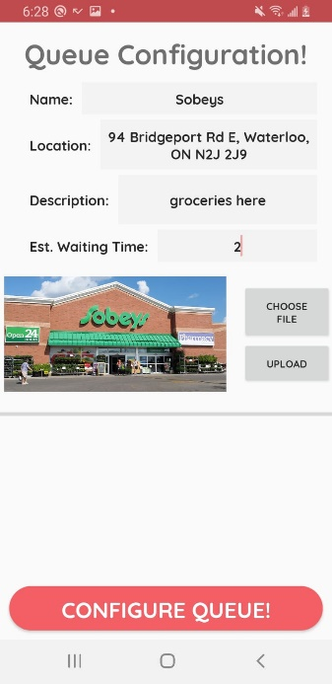

# Database

Firebase is a platform developed by Google for creating mobile and web applications. It was originally an independent company founded in 2011. In 2014, Google acquired the platform and it is now their flagship offering for app development. The Firebase Realtime Database lets you build rich, collaborative applications by allowing secure access to the database directly from client-side code. Data is persisted locally, and even while offline, real time events continue to fire, giving the end user a responsive experience.

We have used authentication, firebase storage and real time database in our project.

**Firebase Authentication:** Firebase Authentication provides backend services, easy-to-use SDKs, and ready-made UI libraries to authenticate users to your app. It supports authentication using passwords, phone numbers, popular federated identity providers like Google, Facebook and Twitter, and more.

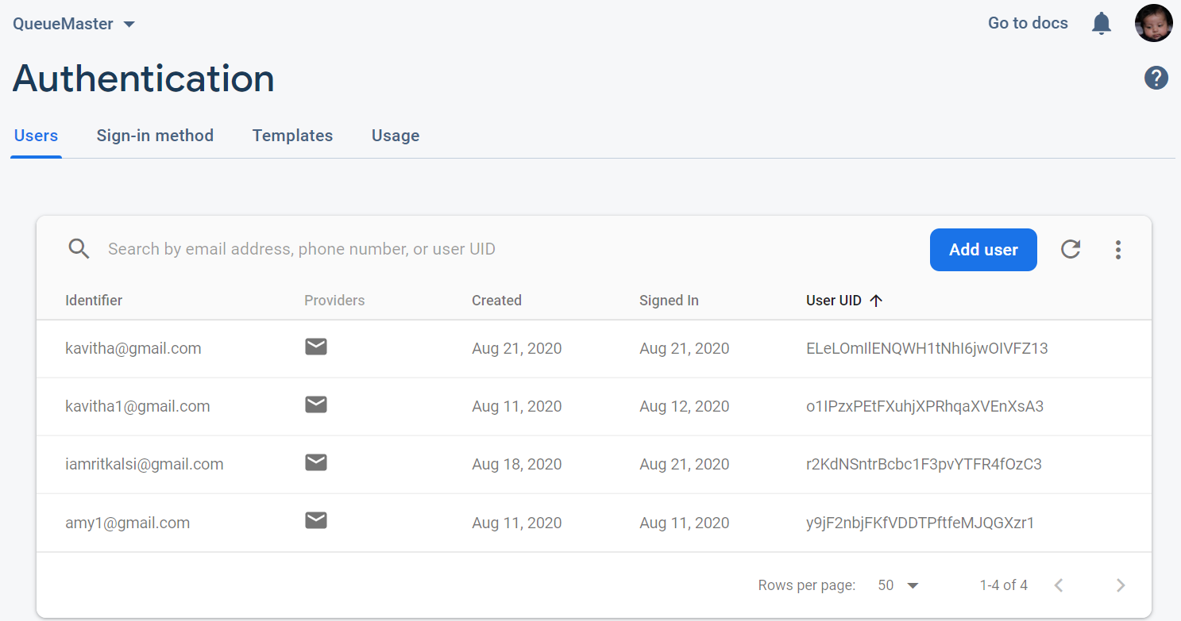

**Firebase Storage:** Storage is built for app developers who need to store and serve user-generated content, such as photos or videos.

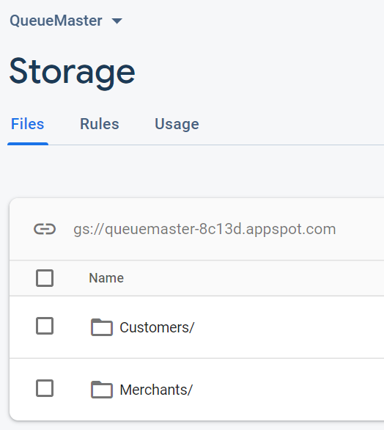

**Realtime Database:** Store and sync data with our NoSQL cloud database. Data is synced across all clients in realtime, and remains available when your app goes offline.

We are storing our tables in json format in firestore cloud. There are two collections. One is Queue and the other is Users.

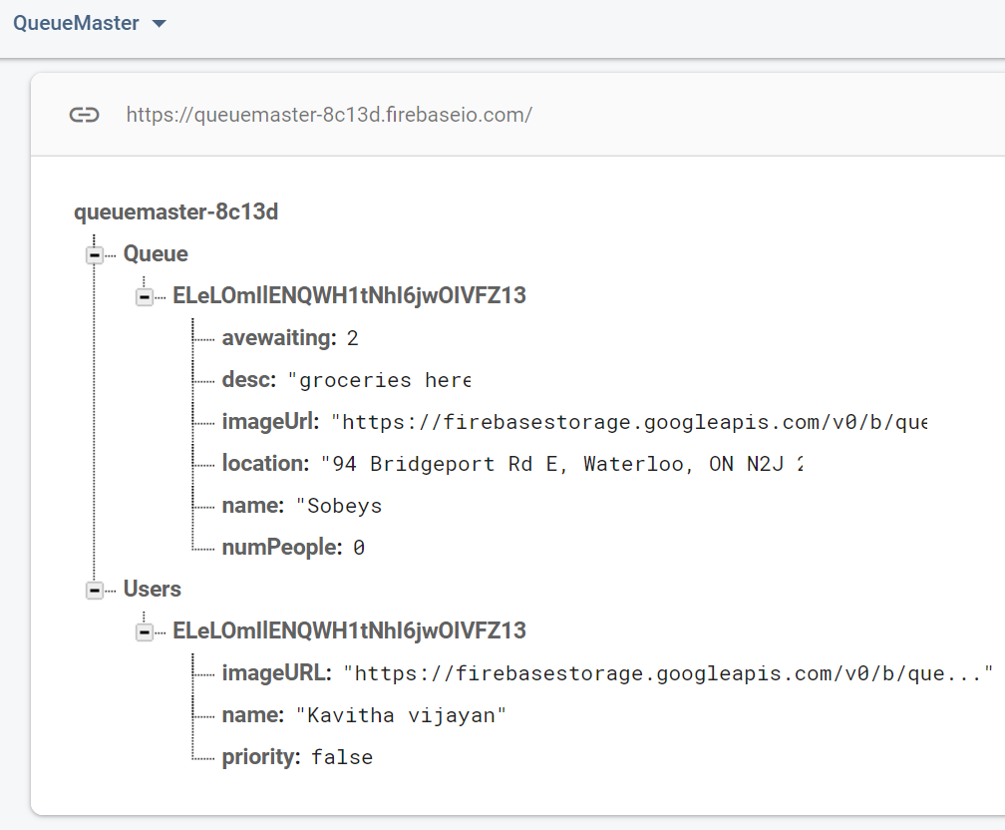

# Conclusions

This Technical Report shows how a combination of a variety of different technologies can lead to an innovative solution that solves common problems. It also describes the features available and technologies used for android application.

# References

Test apps on Android:   Android Developers. (n.d.). Retrieved August 23, 2020, from <https://developer.android.com/training/testing>